VISHWAKARMA UNIVERSITY
Survey No. 2, 3, 2, Laxmi Nagar, Kondhwa Budruk, Pune – 411 048
Maharasthra, India.


A Project Report on,
Exploratory Data Analysis and Visualization of Big Basket Product Dataset

By,
Vaibhavi Admane
(SRN:31241444)

Guided By
Dr. Jagadish Tawade

On the Subject
Research Project

Project No. - 1

For the Programme
S. Y. M. SC. (Statistics-Data Science)

In the Year
2025-26

Pursued in
Department of Computer Science
Faculty of Science & Technology
Vishwakarma University, Pune

CERTIFICATE
This is to certify that the work incorporated in the Project entitled “Exploratory Data Analysis and Visualization of Big Basket Product Dataset” submitted to Vishwakarma University, Pune by Vaibhavi Admane for the completion of the course Research Project was carried out by her under my supervision in the Department of Computer Science, Faculty of Science and Technology, Vishwakarma University, Pune, Maharashtra, India. This work was not previously submitted by him/her to this or any other University for the award of any Degree, Diploma, Associateship or any other similar title.

Place: Pune Dr. Jagadish Tawade
Date: Thursday, November 13, 2025 Course Coordinator

DECLARATION
I hereby declare that the present research work in the form of project report entitled “Exploratory Data Analysis and Visualization of Big Basket Product Dataset”, is an original work carried out by me under the guidance of Dr. Jagadish Tawade, Assistant Professor, Department of Computer Science, Faculty of Science and Technology, Vishwakarma University, Pune, Maharashtra, India for the completion of the course Research Project.

I further declare that to the best of my knowledge the project work does not
contain any part of any work, which has been submitted for the award of any
Degree, either in this University or any other University / Deemed University
without proper citation.

I further declare that the material referred from other sources has been
duly acknowledged in the project report.

Place: Pune Vaibhavi Admane
Date: November 13, 2025 Srn No -31241444

ABSTRACT
The rapid growth of online grocery platforms such as BigBasket, Blinkit, and Zepto has intensified the role of data analytics in understanding customer preferences, pricing patterns, and market demand. This project focuses on performing Exploratory Data Analysis (EDA) and Visualization on a comprehensive BigBasket product dataset containing 27,555 records and 10 attributes, including product category, brand, sale price, market price (MRP), ratings, and subcategories.
The study begins with thorough data preprocessing to handle missing values, remove duplicates, and ensure consistency. Using Python libraries such as Pandas, NumPy, Matplotlib, and Seaborn, various statistical and graphical techniques—including histograms, bar charts, scatter plots, boxplots, correlation heatmaps, and category–subcategory matrices—were applied to uncover important patterns related to pricing, product availability, category dominance, and customer ratings.
The results reveal a highly skewed price distribution, strong positive correlation (0.97) between sale price and MRP, consistently high ratings across categories, and major category dominance by Beauty & Hygiene, Gourmet & World Food, and Kitchen, Garden & Pets.
These insights provide valuable inputs for pricing optimization, category planning, discount strategies, and overall decision-making for e-commerce businesses.

INDEX
Sr. No. | Content
1. | Introduction  1.1 Objective
2. | Literature Survey
3. | Methodology
4. | Data Visualization Techniques
5. | 5.1 Conclusion  5.2 Future Scope
6. | References

CHAPTER 1
1.1 Introduction
In the digital commerce ecosystem, online grocery platforms play a critical role in fulfilling daily consumer needs. BigBasket, one of India's most widely used online grocery services, provides thousands of products across categories including foodgrains, snacks, beauty & hygiene, cleaning, beverages, baby care, and fresh produce.
The availability of such large and diverse product data highlights the need for structured Exploratory Data Analysis (EDA) to understand pricing variations, product categorization, brand presence, consumer ratings, and product distribution.
The BigBasket dataset explored in this project contains 27,555 product records with essential attributes such as product name, brand, category, subcategory, sale price, market price, rating, and product type. Through systematic EDA, this project aims to derive meaningful insights and visual interpretations of the dataset.
Techniques such as distribution analysis, summary statistics, correlation mapping, category-level and brand-level evaluations, and scatter-based relationship analysis are employed. The study demonstrates how EDA transforms raw product data into actionable information that can support effective decision-making in e-commerce operations, pricing strategy, and consumer experience improvement.

1.1 Objective
The primary objectives of the project are as follows:
- To perform thorough data cleaning and preprocessing of the BigBasket product dataset, including handling missing values and removing duplicates.
- To carry out Exploratory Data Analysis (EDA) to understand the structure, distribution, and relationships among key attributes.
- To apply graphical visualization techniques such as histograms, barplots, scatterplots, boxplots, and heatmaps for improved interpretation.
- To analyze category-wise and brand-wise product distribution within the BigBasket platform.
- To study pricing patterns, comparing sale price and market price distributions.
- To evaluate customer ratings and identify trends across categories.
- To examine correlations between numeric variables (MRP, sale price, ratings).
- To present concise insights that can assist e-commerce companies in pricing, product cataloging, and decision-making.

CHAPTER 2
Literature Survey
Data analytics has become a key driver in decision-making for online retail and e-commerce industries. Several studies emphasize the importance of EDA and visualization in understanding large datasets.
Tukey (1977) first introduced the significance of exploratory data analysis as a means of uncovering patterns and extracting insights from raw data. According to Han et al. (2012), EDA is essential in data mining because it helps analysts understand the underlying structure before applying predictive modeling.
Gupta et al. (2019) highlighted how visualization supports real-time evaluation of inventory, pricing, and product availability. In the context of online grocery platforms, datasets containing prices, discounts, and product categories have been used for optimization studies. For example, Kumar & Rani (2020) demonstrated how discount trends in e-commerce datasets can be analyzed through EDA to improve promotional strategies.
Yadav & Singh (2023) emphasized that EDA helps businesses understand demand variations and category-wise product performance in online grocery retailing.
In alignment with these studies, this project uses EDA and visualization to analyze BigBasket’s product dataset and uncover insights into pricing, discount behavior, rating patterns, and category-wise variations.

CHAPTER 3
Methodology
The methodology adopted in this project includes multiple systematic steps:
1. Data Collection
The dataset used in this study is “BigBasket Products.csv”, containing 27,555 rows and 10 columns. The dataset includes product-level attributes such as product name, brand, category, sale price, market price, rating, and description.
2. Data Preprocessing
The following steps were performed:
- Handling missing values
  - product: 1 missing
  - brand: 1 missing
  - description: 115 missing
  - rating: 8026 missing → replaced with median
- Removing duplicates
- Converting datatypes where necessary
- Ensuring numeric fields contain valid values
3. Exploratory Data Analysis (EDA)
EDA steps performed:
- Summary statistics
- Distribution analysis (sale price, market price, ratings)
- Category-wise counts
- Brand-wise comparisons
- Price-rating relationship
- Numeric correlation analysis
- Category–subcategory matrix
4. Data Visualization
Visualization tools & techniques:
- Histograms for price & rating distribution
- Bar plot for category & brand counts
- Scatterplot for sale price vs rating
- Boxplots for brand-wise price distribution
- Heatmap for correlation between numeric variables
- Category vs Subcategory heatmap

5. Tools & Technologies
Tool | Purpose
Python | Programming
Pandas, NumPy | Data cleaning & analysis
Matplotlib, Seaborn | Visualization
Jupyter Notebook | Development environment

CHAPTER 4
Data Visualization Technique
This section presents the graphical techniques used to visually explore the BigBasket product dataset. Each visualization was selected based on the type of variables analyzed and the insights required. All graphs were generated using the dataset after preprocessing, and every figure is explained below in detail.
1. Histogram of Sale Price
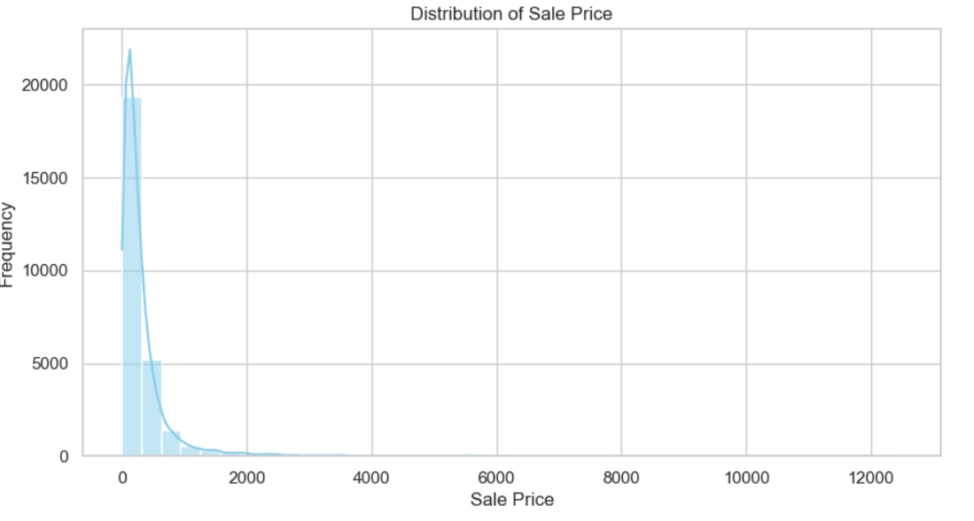
The histogram of Sale Price provides a clear overview of how product prices are distributed on BigBasket. This visualization helps identify whether prices are concentrated in lower ranges or spread out across high value categories.
Interpretation:
- Most products fall within a lower to medium price range.
- The distribution is right-skewed, meaning a small number of high-priced products exist.
- This suggests that BigBasket mostly offers everyday affordable goods.

2. Histogram of Market Price
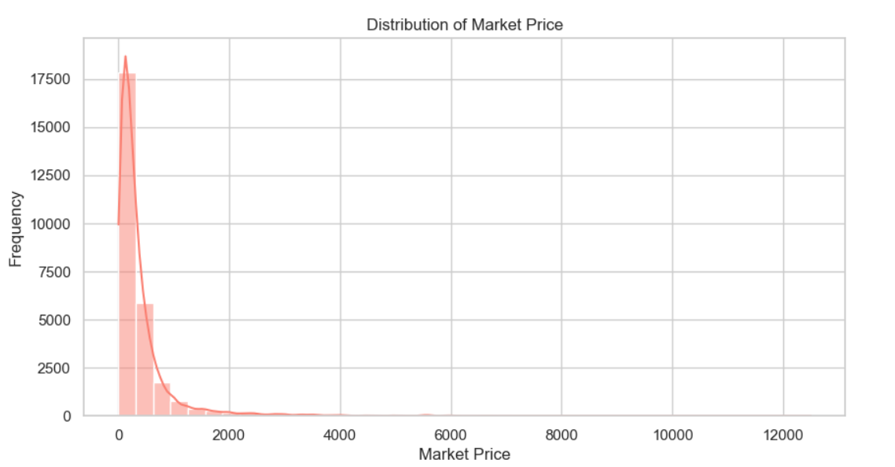

The histogram of Discount Percent displays how frequently different discount ranges occur across the dataset.
Interpretation:
- A high number of products have low to moderate discounts (typically 0%–20%).
- Very high discounts are rare, indicating that BigBasket uses limited deep discounting.
- This helps understand the platform’s pricing and promotional strategies.

3. Boxplot of Ratings
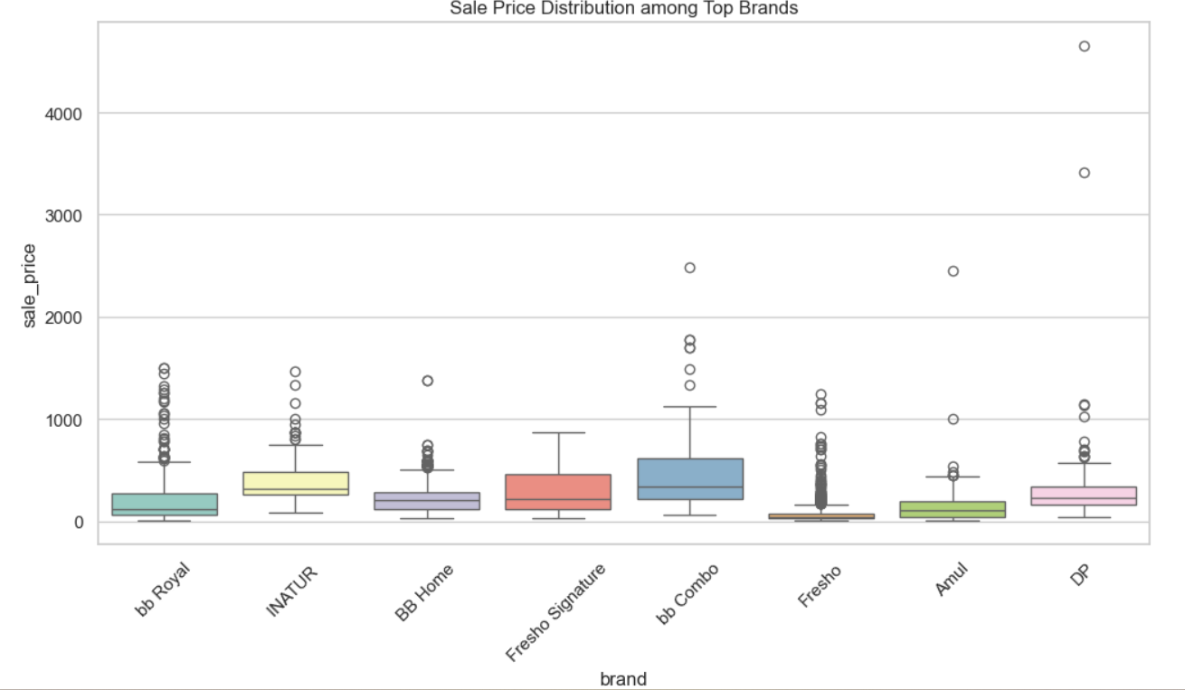
This boxplot summarizes the statistical distribution of product ratings.
Interpretation:
- The median rating is above average, showing that most products are well-received.
- The interquartile range is narrow, meaning ratings do not vary widely.
- Some outliers indicate certain poorly rated products.
- This helps identify product quality trends and customer satisfaction levels.

4. Bar Chart – Top 10 Categories by Product Count
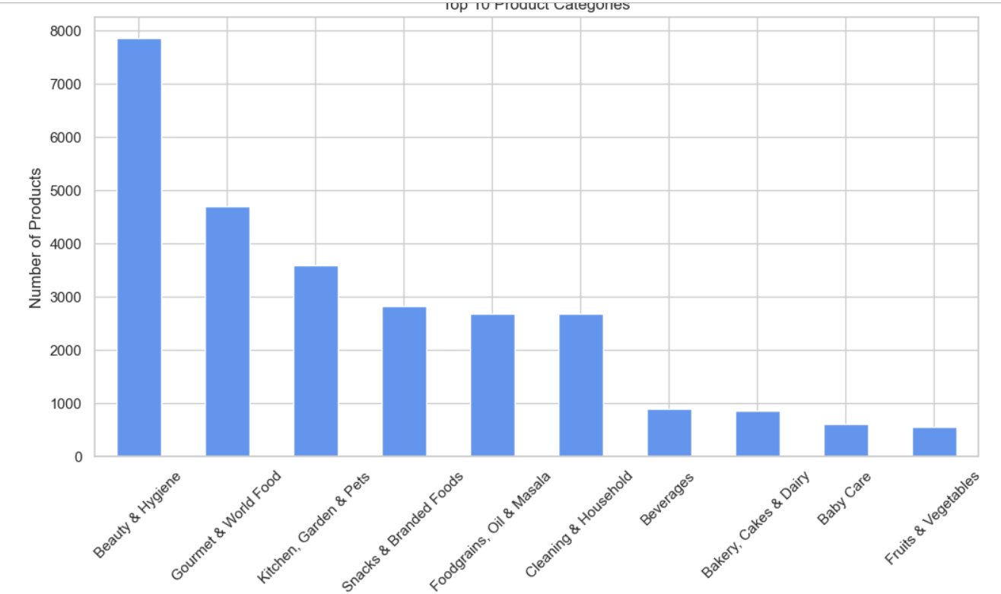This horizontal bar chart shows the top 10 categories with the highest number of listed products.
Interpretation:
- Certain categories dominate the product catalog.
- This helps identify which areas have the widest assortment.
- Useful for understanding consumer demand or platform focus.

5. Bar Chart – Top 10 Brands by Product Count
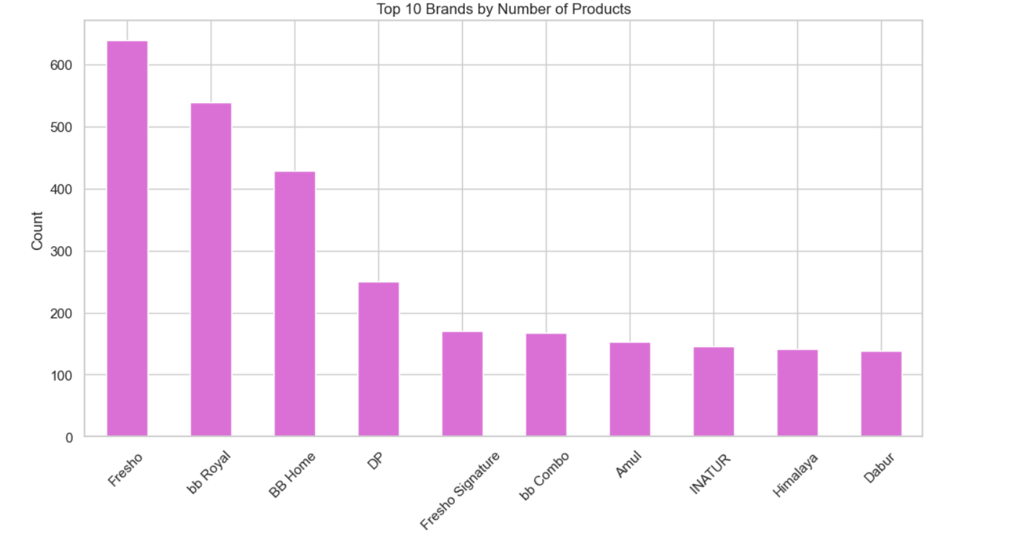This chart highlights the most frequently occurring brands on BigBasket.
Interpretation:
- Some brands contribute significantly more products than others.
- Helps identify brand dominance and assortment richness.
- Useful for studying brand-level competition and visibility.

6. Correlation Matrix Heatmap
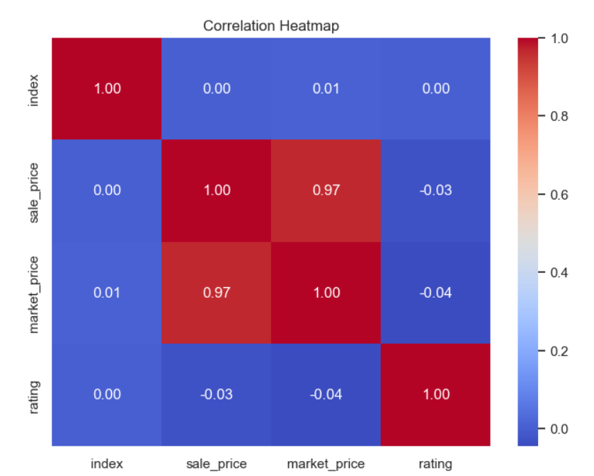
The correlation matrix visually represents the relationship between numerical variables such as:
- Sale Price
- MRP
- Discount Percent
- Rating
7. scatter plot – Proce vs Ratings
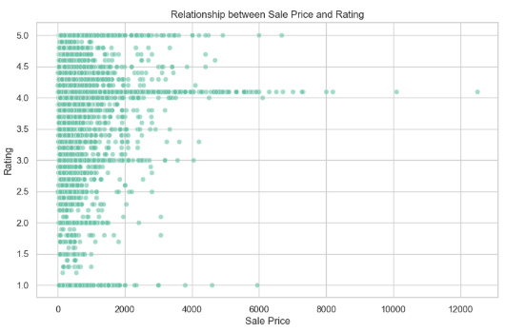

- Most products are priced below ₹2000.
- Ratings are concentrated between 4.0–4.5.
- No clear relationship between price and rating.
- High-priced products do not receive higher ratings.
- Customer satisfaction remains consistent across all price ranges.

8.Boxplot – Brand-wise Price Distribution

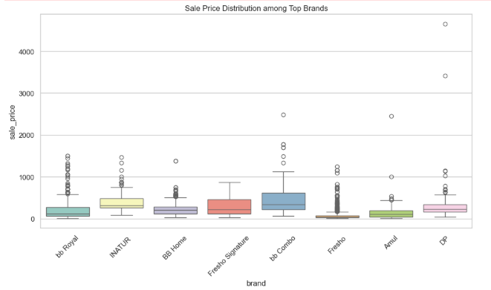
- Fresho Signature, BB Combo show wide price variation
- Amul, NATUR show stable, low price ranges

CHAPTER 5
5.1 Conclusion
This project applied Exploratory Data Analysis and visualization techniques to the BigBasket product dataset, revealing strong pricing patterns, category dominance, and customer rating behaviors. The dataset shows a right-skewed distribution of both sale price and market price, with most products being affordable and within lower price ranges.
The category-wise analysis shows that Beauty & Hygiene dominates the product catalog, while private BigBasket brands such as Fresho, BB Royal, and BB Home contribute heavily to the platform’s inventory. Ratings are consistently high (4.0–4.3 on average), indicating positive customer experience.
The correlation heatmap revealed a strong relationship between sale price and market price, confirming that discounts are structured proportionately. Rating values show no strong dependency on price, indicating independent consumer evaluation.

5.2 Future Scope
- The analysis can be extended by building predictive models to forecast demand and identify future pricing trends.
- More advanced visualization dashboards using Power BI or Tableau can be created for real-time monitoring of product performance.
- Customer reviews (if available) can be analyzed using NLP techniques to understand sentiment beyond numerical ratings.
- Machine learning techniques such as clustering can be used to group similar products or customer segments for better targeting.
- Time-based data, when available, can help study seasonal patterns and improve inventory planning.
- Recommendation systems can be developed to suggest products based on category, brand, and rating similarities.

Big basket dataset, https://www.kaggle.com/code/ridamahmood005/indian-grocery-supermarket-big-basket-eda

REFERENCES
- Chevalier, J. A., & Mayzlin, D. (2006). The effect of word of mouth on sales: Online book reviews. Journal of Marketing Research, 43(3), 345–354.
- Chen, Y., & Xie, J. (2008). Online consumer review: Word-of-mouth as a new element of the marketing communication mix. Management Science, 54(3), 477–491.
- Bronnenberg, B. J., Dubé, J. H., & Gentzkow, M. (2012). The evolution of brand preferences: Evidence from consumer migration. American Economic Review, 102(6), 2472–2508.
- Feng, H., Bhargava, H. K., & Pennock, D. M. (2018). New metrics for online reputation: The role of rating volume. Information Systems Research, 29(3), 594–612.
- Grewal, D., Roggeveen, A. L., & Nordfält, J. (2017). The future of retailing. Journal of Retailing, 93(2), 169–181.
- Tukey, J. W. (1977). Exploratory data analysis. Addison-Wesley Publishing Company.
- Ringel, D. M., & Skiera, B. (2016). Online grocery retailing: Price competition and promotional strategy. Electronic Markets, 26(3), 219–234.
- Behrens, J., & Yu, C. H. (2003). Exploratory data analysis: A perspective from education. In C. Reading (Ed.), Data and Context in Statistics Education.
- Xime, A. (2018). Factors affecting online shopping behavior of consumers. XIME Research Journal.
- Duan, W., Gu, B., & Whinston, A. (2008). Do online reviews matter? An empirical investigation of panel data. Decision Support Systems, 45(4), 1007–1016.

